Math III Unit 3 Part 1: QUADRATIC MODELING AND EQUATIONS
Lauren Winstead, Heritage High School

Main topics of instruction:
1) The Real Number System
2) Factoring and solving quadratic equations
3) Graphing quadratic equations
4) Complex Numbers

Day 1: The Real Number System and Factoring

There are two types of real numbers: _________________ numbers and _______________ numbers. Every real number can be graphed as a point on the number line.
$$-\frac{3}{2}$$
$$\sqrt{5}$$
$$-4$$
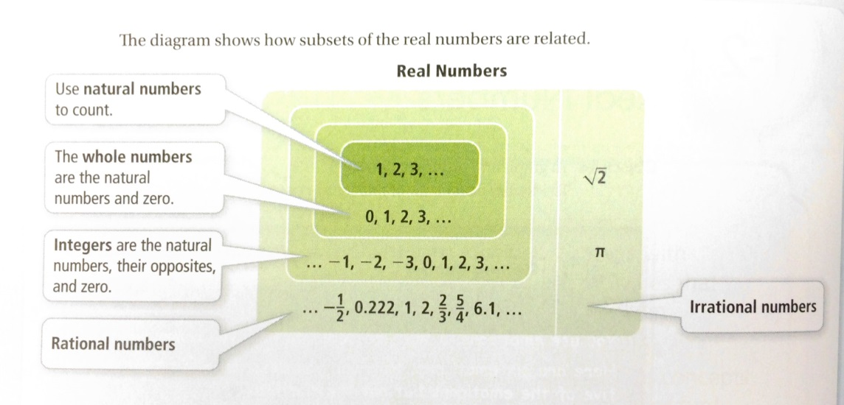
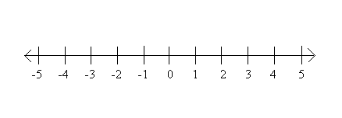

Rational Numbers Irrational Numbers

Classify the following as rational or irrational. If a number is rational, state if it is a natural number, whole number, integer, or simply rational.

- 4 b) -3 c) $\sqrt{6}$ d) 0.125

e) $\frac{-2}{5}$ f) $\sqrt{\frac{1}{4}}$ g) 0 f) π

Critical Thinking: In each scenario, answer Always, Sometimes, or Never. If the answer is Sometimes, give examples of each outcome.

- The sum of a rational number and a rational number is a rational number.

- The product of two rational numbers is a rational number.

- The sum of a rational number and an irrational number is an irrational number.

- The product of a rational number and an irrational number is an irrational number.

- The sum of two irrational numbers is an irrational number.

- The product of two irrational numbers is an irrational number.

Factoring – Quadratics

Greatest Common Factor (GCF): ________________________________________________

____________________________________________________________________________.

Example 1: You try!

Factor and solve $4w^{2}+2w=0$ Factor and solve $5x^{2}-15x=0$

Standard form of a quadratic expression: _________________________________

Example 2: Factor and solve $x^{2}+8x+7=0$

You try! Factor and solve the following.

- $x^{2}-17x+72=0$ b) $3x^{2}-16x+5=0$ c) $9x^{2}-16$

Quick! Throw these in a calculator! What do you notice about where the parabolas cross the x-axis?

_____________________________________________________________________________

These are called zeros! They are also called ________________________________________.

Factoring – Polynomials

Example 1: Factoring Using the GCF You try!

Factor and solve $2x^{3}-22x^{2}+48x=0$ Factor and solve $3x^{3}+15x^{2}-42x=0$

Example 2: Factoring Using Grouping You try!

Factor and solve $2x^{3}-3x^{2}-8x+12=0$ Factor and solve $3x^{2}+12x^{2}-2x-8=0$

Day 2: Finding the Equation of a Parabola in Standard Form

The graph of a quadratic function is called a ____________________.

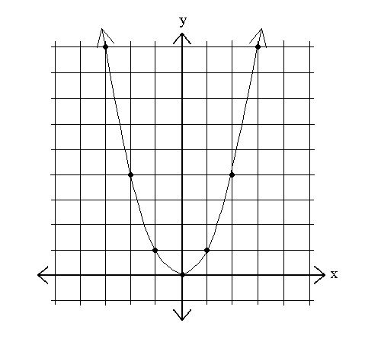

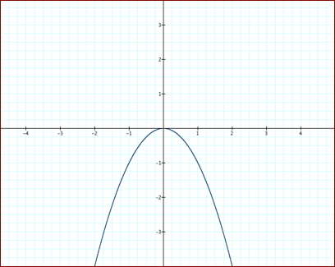

$$y=x^{2} y=-x^{2}$$

Standard Form of a Quadratic Function: _____________________________

Axis of Symmetry: _____________________________________________________

Can be found with the formula:

Vertex: _______________________________________________________________

How can I find the y value of the vertex? ____________________________________
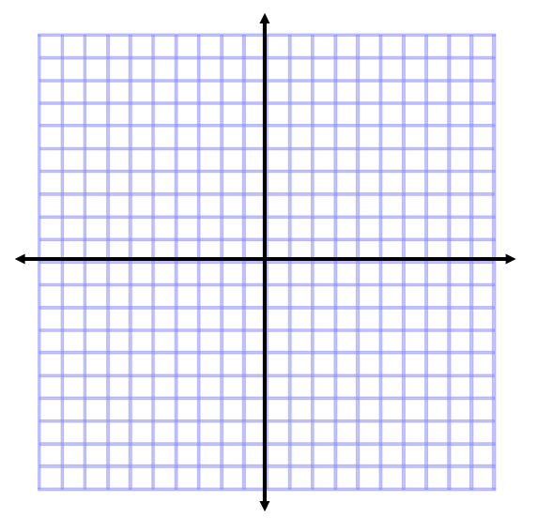
Example 1: Find the vertex and axis of symmetry,
then graph $y=x^{2}+2x+3$

You try! Find the vertex and axis of symmetry, then graph $y=-2x^{2}+6x-4$.

Finding a Quadratic Equation in Standard Form

Example 2: A parabola has three points: (2, 3), (3, 13), and (4, 29). Find a quadratic equation (model) in standard form that will fit the parabola.

You try! A parabola has three points: (1, 0), (2, -3), and (3, -10). Find a quadratic equation (model) in standard form that will fit the parabola.

Example 3: Anthony throws a football across the field while standing on top of the bleachers. The data that follows gives the height of the ball in feet versus the seconds since the ball was thrown.
time | .2 | .6 | 1 | 1.2 | 1.5 | 2 | 2.5 | 2.8 | 3.4 | 3.8 | 4.5
height | 92 | 110 | 130 | 134 | 142 | 144 | 140 | 132 | 112 | 90 | 44

Write a quadratic model for this data. (Round to two decimal places.)

Day 3: Vertex Form and Translating Parabolas

Standard Form of a Parabola: ________________________________

Vertex Form of a Parabola: ____________________________ where the vertex is ( , ).

Using Vertex Form to Graph
Example 1: Graph $y=-\frac{1}{2}{\left(x-2\right)}^{2}+3$.

Where is the vertex? ___________

You try! Graph $y=2{\left(x+1\right)}^{2}-4.$

Where is the vertex? ___________

Writing the Equation of a Parabola in Vertex Form

Example 2: Write the equation of the parabola given the graph.

Step 1: Plug the vertex into vertex form.

Step 2: Use one other point to solve for a.

You try! Write the equation of the parabola given the graph.

Converting from Standard Form to Vertex Form

Example 3: Convert $y=4x^{2}+26$ to vertex form.

Step 1: Find the vertex.

Step 2: Plug the vertex into vertex form and pull a from the standard form equation.

You try! Convert $y=2x^{2}-6x+3$ to vertex form.

Critical Thinking: How would you convert from vertex form back to standard form?

Identifying Translations of Parabolas from Vertex Form
Rules for Transformations:

Inside the parentheses Inverse of what you think
Negative #
Positive #

Outside the parentheses Obvious movement
Negative #
Positive #

Negative coefficient

Integer coefficient

Coefficient $0<a<1$ (fraction)
Graph $y=x^{2}$, then graph $y=-3{\left(x-4\right)}^{2}+6$.

What is different about the two graphs?

Day 4: Focus and Directrix

A parabola has two more important features known as the focus and the directrix.

Focus: ______________________________________________________________________________

_____________________________________________________________________________.

Directrix: _____________________________________________________________________

_____________________________________________________________________________.

The distance between the vertex and the focus is called the ____________________.

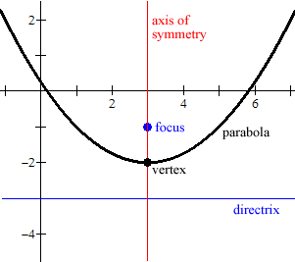

Example 1: Find the equation of the parabola with vertex at the origin and focus (0, 2).

Draw a picture first!

Example 2: What are the focus and directrix of the parabola with equation $=-\frac{1}{12}x^{2}$ ?

You try! a) What is the equation of a parabola with vertex at (0, 0) and focus (0, -1.5)?

b) What are the vertex, focus, and directrix of the parabola with equation $y=\frac{x^{2}}{4}$?

Example 3: What are the vertex, focus, and directrix of the parabola with equation $y=x^{2}-4x+8$?

First, get the equation in _________________!

You try! a) What are the vertex, focus, and directrix of the parabola with equation
$y=x^{2}+8x+18$?

- What are the vertex, focus, and directrix of the parabola with equation $y={2x}^{2}+4x-2$?

Day 5: Completing the Square & Quadratic Formula

Completing the Square is _________________________________________________________

_____________________________________________________________________________.

Example 1: Solve $x^{2}+6x-7=0$ by completing the square.

Step 1: Move the constant to the other side.

Step 2: Compute ${\left(\frac{b}{2}\right)}^{2}$and add the result to both sides of the equation.

Step 3: Convert the left side to a binomial squared and simplify the right side.

Step 4: Square root both sides, and don’t forget the $±$ on the right side!

Step 5: Solve for x. Remember that the $±$ gives you two solutions!

Example 2:

- Solve ${2a}^{2}+12a+10=0$ by completing the square.

You try! Solve the following by completing the square. (It’s okay to get decimals!)

- $n^{2}+13n+22=7$ b) $4v^{2}+16v=65$

The Quadratic Formula

How many solutions? _____ How many solutions? _____ How many solutions? _____
Type: __________________ Type: _________________ Type: __________________
Discriminant is: __________ Discriminant is: __________ Discriminant is: __________

The quadratic formula is _________________________________________________________

_____________________________________________________________________________

What is the quadratic formula? Circle the discriminant!

Example 1: Use the discriminant to find the number and types of solutions to the quadratic expression. Remember to get all terms on one side and in standard form!

a) 3x² – 5x - 18 b) 4x² + 5 = 2x c) 2x² = 3x – 12

Example 2: Use the quadratic formula to solve $3x^{2}-5x=2$. Then, sketch the graph using what you know about the vertex and parabolic transformations.

You try! Use the quadratic formula to solve $5x^{2}+8x-11=0$. Then, sketch the graph using what you know about the vertex and parabolic transformations.

You try! Use the quadratic formula to solve $9x^{2}-11=6x$. Then, sketch the graph using what you know about the vertex and parabolic transformations.

Modeling Using Quadratics
2) The equation $h=-16t^{2}+40t$ describes the height h, in feet, of a ball that is thrown straight up as a function of the time t, in seconds, that the ball has been in the air.

At what time does the ball reach its maximum height?

What is the maximum height?

When does the ball hit the ground?
1) Each year, Heritage’s Homecoming committee organizes a dance. Based on previous years, the organizers decided that the Income from ticket sales, I(t) is related to ticket price t by the equation I(t) = 400t – 40t².

What ticket price(s) would generate the greatest income? What is the greatest income possible?
Ticket price(s) ______________
Income ________________

Day 6: Complex Number Operations

You already know about real numbers (rational and irrational), but there are also ______________ numbers that use the letter ____.

$$i=$$
$$i^{2}=$$
$$i^{3}=$$
$$i^{4}=$$

Simplifying Using $i$

Example 1: Simplify $\sqrt{-8}$.

You try! Simplify the following: a) $\sqrt{-12}$ b) $\sqrt{-13}$

Simplifying Complex Numbers

Standard Form of a Complex Number:

Example 2: Write $\sqrt{-9}+6$ in standard form.

You try! Write $-\sqrt{-50}-2$ in standard form.

Adding and Subtracting

Example 3: Simplify $\left(5+7i\right)+(-2+6i)$

You try! a) Simplify $\left(-4+6i\right)+(3-2i)$ b) Simplify $\left(8+3i\right)-(2+4i)$

Multiplying Complex Numbers

Example 4: Simplify $(5i)(-4i)$.

You try! Simplify $(12i)(7i)$.

Example 5: Simplify $(2+3i)(-3+5i)$. F:
O:
I:
L:

You try! a) Simplify $(6-5i)(4-3i)$. b) Simplify $3i(9-4i)$. c) Simplify ${\left(8-2i\right)}^{2}$.

Rationalizing

There is one big rule for complex number, and that is that _______________________________

_____________________________________________________________________________.

Why do you think this is? ________________________________________________________

_____________________________________________________________________________

Why do you think we call it rationalizing? ___________________________________________

Rationalizing with One Term in the Denominator

Example 6: Simplify $\frac{3+8i}{5i}$ You try! Simplify $\frac{4-2i}{-6i}$

What is a complex conjugate?

Why do we use it?
Rationalizing with a Binomial in the Denominator

Example 7: Simplify $\frac{4i}{6+2i}$ You try! Simplify $\frac{(2+3i)}{(5-2i)}$

Day 7: Finding Complex/Imaginary Solutions

Quick review! Sketch the type of parabola that would have complex/imaginary roots.
Why does this parabola have imaginary roots?

Let’s solve some quadratic equations that have complex solutions!

Example 1: Solve $4x^{2}+100=0$.

You try! a) Simplify $3x^{2}+48=0$ b) Simplify $-5x^{2}-150=0$

Example 2: Solve $2x^{2}=-6x-7$ You try! Solve $6x^{2}-3x+2=0$

Quadratic Equation | Value of Discriminant  (show work!) | Number of Solutions (or roots) | Types of Solutions (or roots) | Using the quadratic formula, what are the roots/solutions/zeros?  (show work!)

