Honors Precalculus Project: Functions and their graphs
Poetry:
Choose a math word. Write the letters vertically. Each line of the poem must begin with the corresponding letter of the title. A word, phrase or sentence may be written on a line.

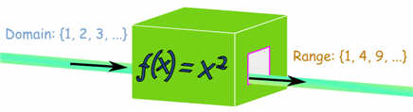
Example:

Do look at the x values
Omit any x values that result in a zero in the denominator
Make sure you use interval notation
A bracket indicated inclusive values and parentheses means non-inclusive
If you have a square root functions, remember no negatives under the radical
No repeating x values means the relation is a function

Choose five words from our chapter one study of functions. For each word chosen, create a poem in vertical form {acrostic poem} and either draw an accompanying picture or attach a computerized image.
Rubric:
Completion of 5 acrostic poems using terminology from functions unit. {50 points}
Poems are neat, attractive, logical, and complete with a graphic. {50 points}

Possible words to use:
- interval notation
- identifying functions
- finding function values
- evaluating piecewise functions
- finding the domain and range from a graph
- finding y intercepts and zeros
- symmetry of graphs
- even and odd functions
- continuity and discontinuity
- increasing, decreasing, and constant behavior
- average rate of change
- parent functions and transformations
- functions operations and composition of functions
- inverse functions

